LOST CAT
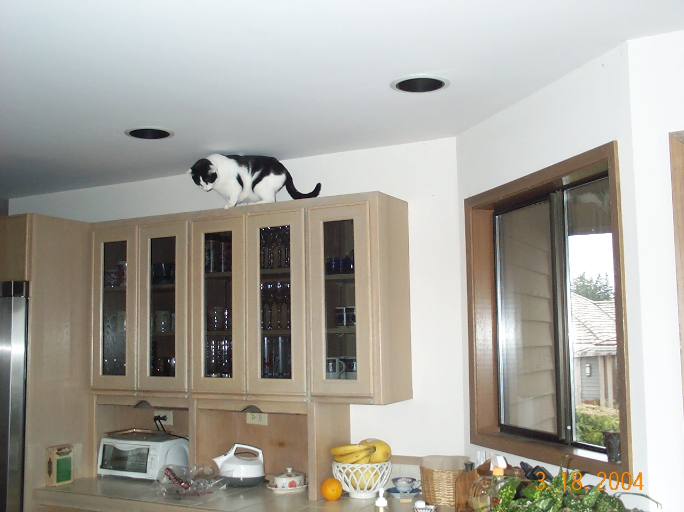 | 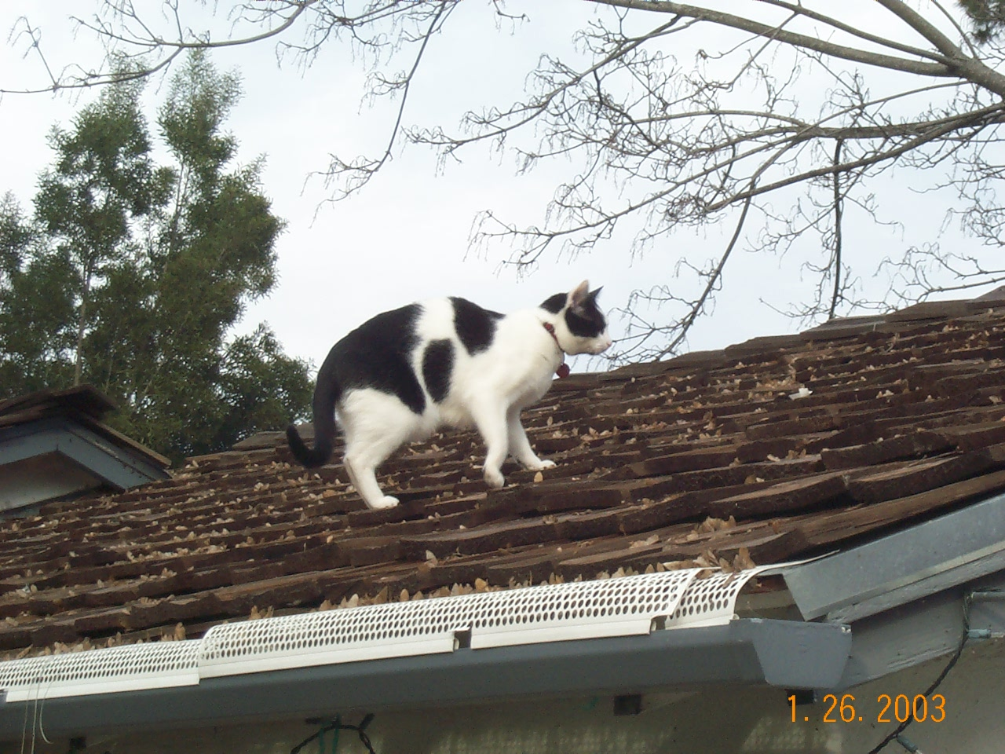
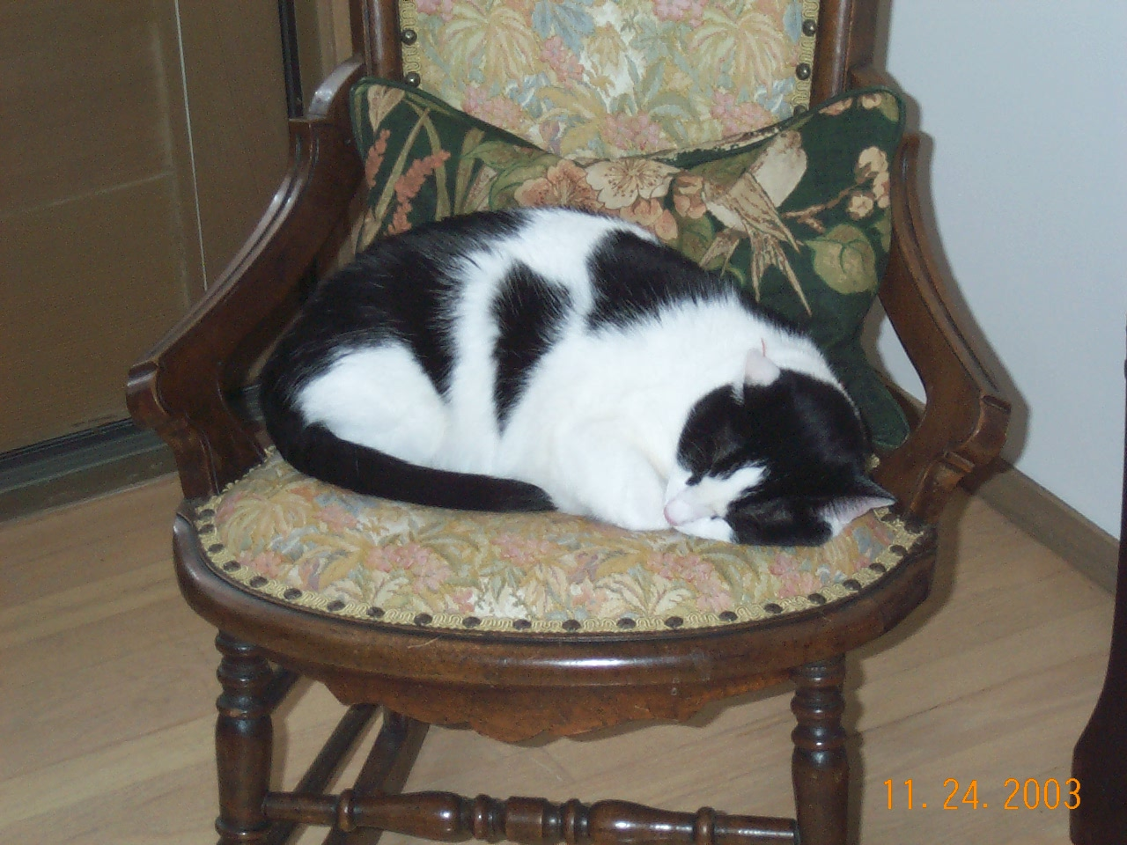 | 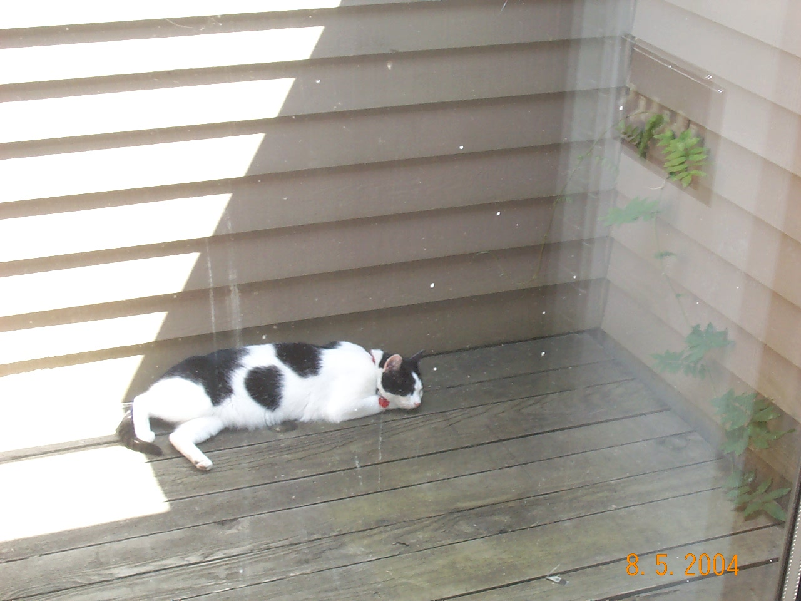
“Enterprise”
Black & White
Short Hair
Shy of Unfamiliar People
Last Seen Tuesday Afternoon
Please call if you’ve seen him!!
(425) 643-0204
Pavel Curtis and Kathleen Kells

