LOST CAT
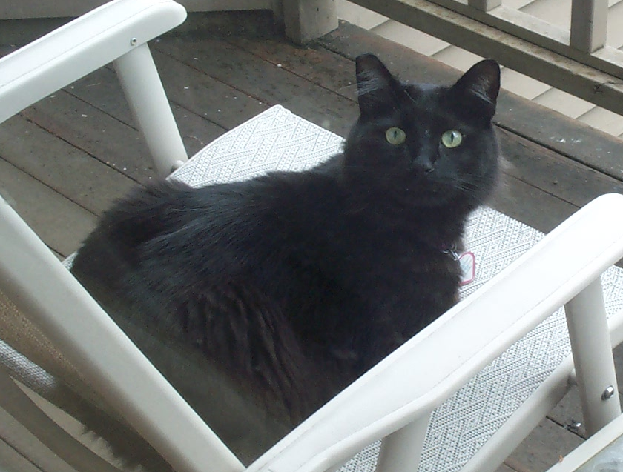 | 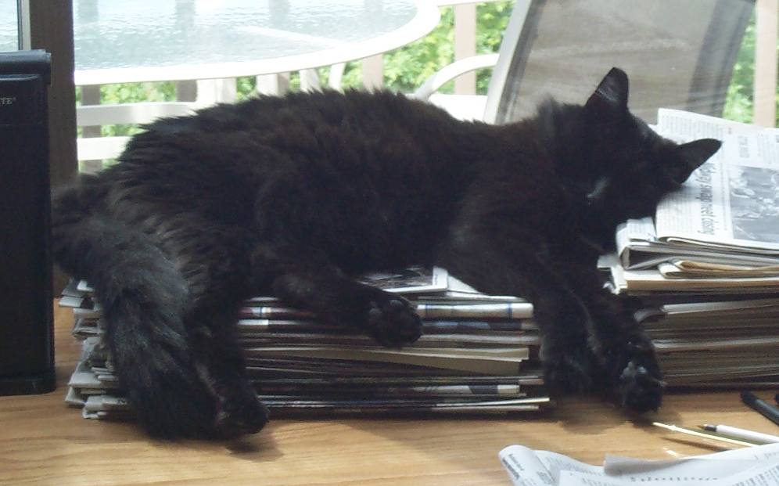
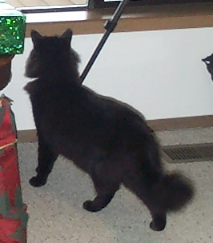 | 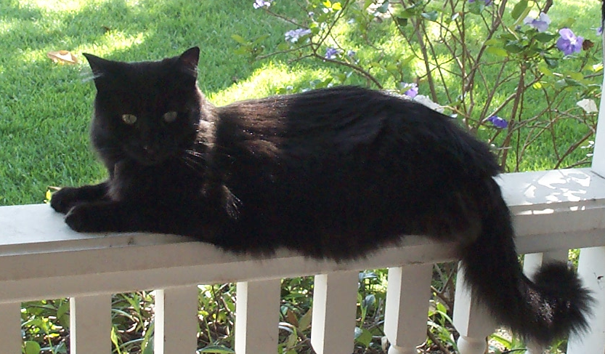
“Zap”
All Black
Large and Bushy, with a Long Tail
Shy of Unfamiliar People
Last Seen Wed. Morning, 11/10/04
Please call if you’ve seen him!!
(425) 643-0204
Pavel Curtis and Kathleen Kells

